Overview  Country or Region: Spain  Industry: Industry  Customer Profile  Nissan registered profits of 6.2 billion euros in 2003 and sold over three million cars.  Business Situation  To manage the engineering changes in the past, Nissan used documents in paper and very basic IT tools.  Solution  Nissan has implemented a project management solution based on Microsoft® Office Enterprise Project Management (EPM) Solution, which makes it possible to manage the nearly 4,000 engineering changes per year in its Barcelona factory.  Benefits  - Time and cost reduction  - Robust, fully integrated, next-generation systems  - Scalability and performance  - User and learning friendly |  |  | “It was vital that the solution should be robust, reliable, and stable and the Microsoft solution has proved to be so….”  Miguel Ángel Martorell, Head of the Design Change Control Department, Nissan
 |  |  | Microsoft® Office Enterprise Project Management (EPM) Solution has been a key factor in building the Design Change Collaborative Management (DCCM) platform for Nissan Motor Ibérica, S.A. It is a tool that enables planning, coordinating, and monitoring the whole complex process of engineering changes introduced in Nissan’s vehicles before they leave the factory. Nissan has moved from using traditional paper files and typical software tools, which each department used to store the partial information related to every single process, to working exclusively with a Web application where information is digitalized and completely visible so that all those involved can consult it whenever necessary.
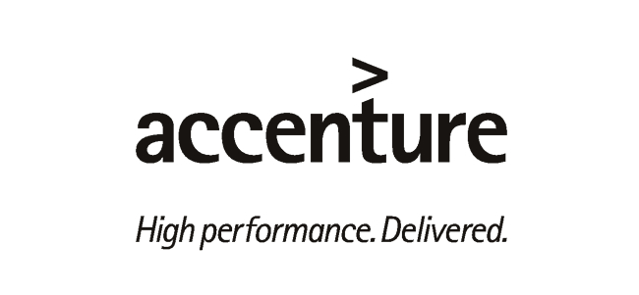 |  |  | 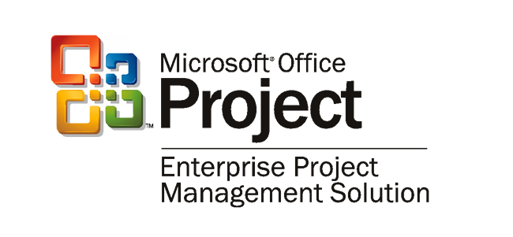

Situation
A car is made up of some 4,000 parts. Any of these parts may need to undergo modifications during the manufacturing process to improve quality or assembly capability, to reduce costs or to adapt to a new market requirement. However minimal these engineering changes may be, carrying them out is a complex process involving different departments (design, production control, quality, production engineering, logistics, materials movement, etc.), other group factories, and outside suppliers, for which interaction is difficult.
“EPM has enabled us to build a user-friendly platform, the working of which has been learned by users without too much effort.”
Jordi Roca, Associate Director, Accenture

To optimally handle the engineering modifications required, both in the new projects and in the ones currently being produced, Nissan Motor Ibérica, S.A. developed the Design Change Control Department (DCC) in 1994. The company saw the need for a central factory unit to coordinate the management of the changes and to mediate among the parties involved. The main objective was to meet all the fixed deadlines with the end result being of the highest quality. “The department in charge had to be one with an overall vision of the process, with the ability to set the priorities, and to distribute the urgent needs among those responsible for a change, at the same time keeping control of the company’s objectives,” remarks Miguel Ángel Martorell, Head of the DCC Department for Nissan.

One of the first and most significant changes introduced by this new department was working through processes. A process is made up of all the activities required to carry out a specific change. These tasks are performed by the different departments within the company. “Every single process has been precisely set, parameterized, and delimited through a series of specific steps to be followed, all this totally coordinated by the DCC,” says Martorell.

Solution
In 2002, the person responsible for the DCC and all the other departments realized that daily work could be improved by using the new information technologies. During the last few years, significant optimization opportunities in process management had become apparent: delays in the timing for the introduction of engineering changes, too many manual management tasks with no added value requiring a lot of human resources, low quality in the information due to the existence of highly dispersed nonshared and not easily accessed data bases, bad communication among the different departments and suppliers, and a difficult and slow reaction to problems.
All this led to Nissan asking Accenture to build a technological platform to manage and coordinate the introduction of engineering changes in the manufacturing processes. “Once the problem had been identified, the first thing we did was to analyze the requirements the new technological solution should include. We came to the conclusion that it should be one open to the Internet, framed within a highly collaborative environment, forced to reach previously agreed deadlines, providing document management and, of course, at reasonable costs,” explains Jordi Roca, Associate Director of Accenture.

With these initial premises, Accenture analysts set out to find a solution that would meet all the requirements. First, they analyzed standard bundle management applications and customized development solutions, but soon they found out that Microsoft® Enterprise Project Management (EPM) Solution, a solution providing visibility, knowledge, and control over all the projects and resources within a company, was the appropriate base for the development of this new tool.

“We realized that every single engineering change is a completely different project, and so we clearly saw that a tool based on Microsoft EPM Solution was perfect to address the needs presented by Nissan’s DCC Department,” Roca points out. “EPM [Solution] has all the typical drive of Microsoft Office Project, but with substantial improvements such as access via the Internet and some very interesting features such as an enlargeable database, productive workflow, and excellent document capability. All this makes it an ideal solution on which to build a customized development layer adapting itself to Nissan’s needs,” he continued.
“Future developments are guaranteed: additional components such as Microsoft SharePoint Portal Server… or Microsoft BizTalk Server… can be built into EPM and this is a very important added value.”
Jordi Roca, Associate Director, Accenture

This is how the development of the Design Change Collaborative Management (DCCM) platform began. DCCM was launched in January 2004 and lasted four months. Its outcome has been a project management solution enabling the handling of the nearly 4,000 parts with engineering changes being carried out by Nissan Motor Ibérica S.A. every year. DCCM is divided into four stages covering all the different steps required for managing and implementing an engineering change: analysis (data capture and analysis, and the establishment of priorities or urgent needs), planning (planning activities and tasks, setting deadlines, and assigning who is responsible for what), control and validation (monitoring planning, checking of incidents, coordinating, replanning, data management, and communication maintenance), and performance and closing (assessment and reporting, critical feedback, and improvement).

“The basic premise governing this tool is that the overall process must always be under control, with DCCM itself being able to inform everybody about when they have
to carry out the task and the time limit to do so,” states Martorell, who at the same time points out the visibility of the information. “The data is always available, so all the departments involved in an engineering change know at once the exact situation of the process.”

The introduction of this platform based on Microsoft EPM Solution represents a complete transformation in the management of engineering changes at Nissan. “From the traditional paper files and department databases in Microsoft Excel and Microsoft Access, which stored partial information related to every single stage within the process, the company has moved to work exclusively with a Web application in which all the data are digitalized and perfectly visible so that all those involved may consult them. “DCCM has been designed as a work desktop solution, so that the tasks to perform and the data are available in a customized form and in real time on every user’s interface, which helps to improve traceability, standardization, and stability for the whole process,” says Martorell.

Thanks to DCCM, the DCC coordinator receives the information related to every change coming from the design department, analyzes it, assesses its urgency and priorities, and immediately delivers it, using the same tool, to the people responsible within the different departments and the suppliers involved, some 200 people in total. “It is a fully integrated operative and documentary collaborative management tool which enables everybody to take on full responsibility for one’s own actions and data, and which includes indicators for each task so that if the deadlines are not met, the alarms go off,” adds Roca. “I have always found it ridiculous having to invest a person’s time in chasing another to make him do his work within the set deadline, now it is the system which does that,” explains Martorell.
DCCM is already being used to introduce modifications to the models that are being made at Nissan Motor Ibérica, S.A. in Barcelona: Terrano, Tino, and Traffic-Primastart-Vivaro. By the end of 2004, and within the framework of the Renault-Nissan alliance, there are plans to implement it in all the Renault factories and its introduction into other Nissan plants is under consideration. “This shows that in Spain we are able to build a platform which is unique in the world and one we hope will become a benchmark within the sector,” says Martorell.

Benefits
Time and Cost Reduction
For the person in charge of the DCC, the main business benefit achieved by Nissan with the implementation of the new platform based on Microsoft Enterprise Project Management Solution is “the reduction of lead-time in the introduction of engineering changes, the response time to emergencies, and the reduction of scrap throughout the process which represents a cost reduction of over 20 percent per year, due to the simplification and improvement of internal management times.”

Robust, Fully Integrated, and Next-Generation Systems
Regarding just the technological benefits achieved through EPM, Martorell points out, first, that the Microsoft solution has enabled the creation of robust, fully integrated IT systems. “It was vital that the solution should be robust, reliable, and stable and the Microsoft solution has proved to be so,” he states. Roca adds the advantages of easy communications and integration with the company’s information technologies and its capability to adapt to future developments: “Future developments are guaranteed: additional components, such as Microsoft SharePoint® Portal Server as document manager or Microsoft BizTalk® Server, to exchange information with other architectures can be built into EPM and this is a very important added value.”

Scalability and Performance
Roca also underlines other important aspects such as scalability, “which allows one to start off with a small server to follow with a cluster for thousands of users,” and performance, “taking the most advantage of the solution so that in the future it will be possible to perform a greater amount of engineering changes with the same number of people.”

User and Learning Friendly
“EPM has enabled us to build a user-friendly platform, the working of which has been learned by users without too much effort,” Roca concludes.
Microsoft Office System
For More Information
For more information about Microsoft products and services, call the Microsoft Sales Information Center at (800) 426-9400. In Canada, call the Microsoft Canada Information Centre at (877) 568-2495. Customers who are deaf or hard-of-hearing can reach Microsoft text telephone (TTY/TDD) services at (800) 892-5234 in the United States or (905) 568-9641 in Canada. Outside the 50 United States and Canada, please contact your local Microsoft subsidiary. To access information using the World Wide Web, go to: www.microsoft.com

For more information about Accenture products and services, call or visit the Web site at:
www.accenture.com

For more information about Nissan products and services, call or visit the Web site at:
www.nissanusa.com

© 2005 Microsoft Corporation. All rights reserved.

This case study is for informational purposes only. MICROSOFT MAKES NO WARRANTIES, EXPRESS OR IMPLIED, IN THIS SUMMARY.

Microsoft, BizTalk, the Office logo, and SharePoint are either registered trademarks or trademarks of Microsoft Corporation in the United States and/or other countries. All trademarks are property of their respective owners.

Document published January 2005

Software and Services
- Microsoft Office System
- Microsoft Office Project 2003
- Microsoft Enterprise Project Management Solution

Microsoft Office is the business world's chosen environment for information work that provides the software, servers, and services that help you succeed by transforming information into impact.

For more information about Microsoft Office System, go to:
www.microsoft.com/office

